

ITAG – Image tagging Software

Version: 0.7.0.1

Authors: Sacha Viquerat & Abbo van Neer

Source code written by: Sacha Viquerat

Maintainer: Sacha Viquerat

Maintainer email: itag.biology[at]yahoo.com

License: GPL

Document Save Date: 24.06.2015 11:19

Word Count: 5277

Contents

2 Ambitions of iTAG 4

3 License and Copyright notice 5

4 Version History (Major releases) 6

5 Restrictions 7

6 Using the software 8

6.1 PREPARING YOUR IMAGES 8

6.2 SAMPLE SESSION 9

6.2.1 SETTING UP A NEW SESSION 9

6.2.2 RESUMING A PREVIOUSLY SAVED SESSION 10

6.3 MAIN INTERFACE 12

6.3.1 MOVING AROUND THE IMAGE 15

6.3.2 TAGGING OBJECTS 15

6.3.3 TAG MODIFIERS 15

6.3.4 REMOVING A TAG 16

6.3.5 MAGNIFIER MODE 17

6.3.6 THE GENERAL PANEL 17

6.3.7 SAVING THE SESSION 17

6.3.8 A FULL SESSION IN PROGRESS 18

6.4 ENDING THE SESSION 19

6.4.1 COLUMNS TO PROCESS 19

6.4.2 PROCESS IMAGES 19

6.4.3 CREATE CSV FILES 19

6.4.4 CREATE GOOGLE EARTHTM KML FILES 19

6.4.5 CREATE SQL FILE 19

7 KEY REFERENCES 20

7.1 KEY REFERENCES - SESSION SETUP 20

7.2 KEY REFERENCES - MAIN INTERFACE 20

7.2.1 KEY REFERENCES - MAGNIFIER MODE 21

8 FAQ 22

# Ambitions of iTAG

iTAG has been designed at the *Institute for Terrestrial and Aquatic Wildlife Research* (ITAW, Werftstr. 6 in 25761 Büsum, Germany) for researchers that rely on photographic census techniques of animals that are hard to detect via image recognition algorithms and was originally developed for counting grey seals in the German Wadden Sea during March 2013. It has since then been further expanded and has now been adopted to meet the demands of a wide spread user base.

iTAG allows users to define up to 9 different categories and name them accordingly. In addition, 4modifiers are available to further increase the options during a tagging session. Option files can be saved to accommodate to different survey setups. Users typically will load a series of images into a session and add tags on objects on these images within previously defined categories and modifiers.

Upon ending the session, result files are produced including (if provided by the EXIF data) the GPS information for each picture, the number of objects in each category and detailed spreadsheets that give insight into the session dataset on various levels of detail. In addition, users can opt to have all images that were tagged saved as well as a legend, in a graphical and in a spreadsheet format. A *sqlite* compatible file that includes all the data and can be viewed with SQLite browsers is produced. Support for Google KML files to be loaded into Google EarthTM is implemented and produces point layers as well as line layers if the user wishes so. All output is written into a folder named after the user created below the image directory. The user can also save the current session and resume later on.

# License and Copyright notice

iTAG is open source under LGPL (due to the PIL Library Copyright © 1997-2011 by Secret Labs AB and Copyright © 1995-2011 by Fredrik Lundh) and may be freely distributed as long as the authors of the program are properly cited (information on how to cite will be made available as soon as possible). iTAG may not be changed in parts or as a whole without previous acknowledgement by the authors themselves.

# Version History (Major releases)

|  |  |
| --- | --- |
| 0.7 | * Complete migration to *sqlite* as data storage * Improved speed and stability * Added support for handling large images (beyond 10k x 10k pixels) * Added static zoom * Added Google EarthTM KML line file output * Added support for group association of tags |
| 0.6 | * Complete UI overhaul * Added output Options * Added new Panel |
| 0.5 | * SQLite backend replaces old storage engine, thus improving speed and flexibility |
| 0.4 | * Options can now be saved and restored * Added new magnifier function and graphics filter |
| 0.3 | * Added output per image * Added options to modify number of categories and modifier names |
| 0.2 | * Added overview panel displaying session summary |
| 0.1 | * All basic functions (adding and removing tags) present |

# Restrictions

* iTAG uses TkInter for all GUI elements, a graphical window manager not at all suited for image display and modification. A possible port to more potent environments such as WinAPI may improve performance in future releases
* While we regard the user interface to be ok, that sentiment may not necessarily apply to all users. We encourage you to submit any suggestions to the authors
* The manual constitutes a work in progress and is far from being comprehensive
* iTAG will read all EXIF data stored within the image files, it will also replace any unavailable field with **None** values. If your camera saves EXIF info in a version non-compliant to EXIF 2.1 or below, please contact the authors
* Image display in python is using up a lot of memory – you will encounter problems when trying to load images that exceed 10000 x 10000 pixels. Reduce image size if possible
* There are two versions of iTAG available: iTAG (the default 32bit application) and iTAG x64 (designed for machines based on 64bit architecture). There are no differences per se between versions. However, the 64bit version allows larger images (beyond 10k x 10k) as there is more RAM available to iTAG. If you consider using iTAG for high res mosaic images or very large images, please also consider the FAQ

# Using the software

## PREPARING YOUR IMAGES

In order to get the most out of iTAG, you should organize your files in folders. Since it is very difficult to implement Unicode file browsing in iTAG, pathnames may only contain ASCII characters (i.e. a pathname like *C:\users\Sacha\Surveys\2014_09_11\Fifth Leg* would be ok, whereas *C:\users\Sacha\Surveys\2014_09_11\f****ü****nfte Runde* raises an error due to the umlaut ***ü***). iTAG works with jpeg & bmp Images. iTAG is **case-insensitive**, so any file ending with **.jpg** / **.bmp** or any upper / lower case version of jpg or bmp will be found. Since iTAG will need to create Subfolders and write to that particular directory, you should also have full read / write access to that folder.

**Don’t put your image folder anywhere that you don’t have access to!**

iTAG will create a subfolder with the name of the user and store all results inside that folder, including copies of all tagged images.

**iTAG will never touch or modify your raw data!**

If your data complies with the EXIF 2.1 or earlier Standard and has geographical data stored, these will be read, otherwise the corresponding fields default to **None**. It is generally a good idea to sort your data by survey date or whatever is applicable for your specific design. Once you have put all your images into one folder, you can then open up iTAG and continue with setting up the session.

As Python is not very good at handling large images, there is a built in limit to the maximum allowed width or height of an image.

**The default maximum image size set to a limit of 10,000 by 10,000 pixels. You can override that setting by supplying iTAG with start-up options. Right Click on your shortcut and change the target from “*itag.exe”* to “*itag.exe” –m5000*, thussetting the maximum side of images to 5,000 by 5,000 pixels (refer to the FAQ Section for more information on how to work with large images).**

## SAMPLE SESSION

### SETTING UP A NEW SESSION

Upon opening iTAG, you will encounter the start page. If you wish to setting up a new session, you’ll need to go to ‘*New Session (Ctrl-N)*’ first by either clicking on *File -> New Session (Ctrl-N)* or by pressing *ctrl + N*

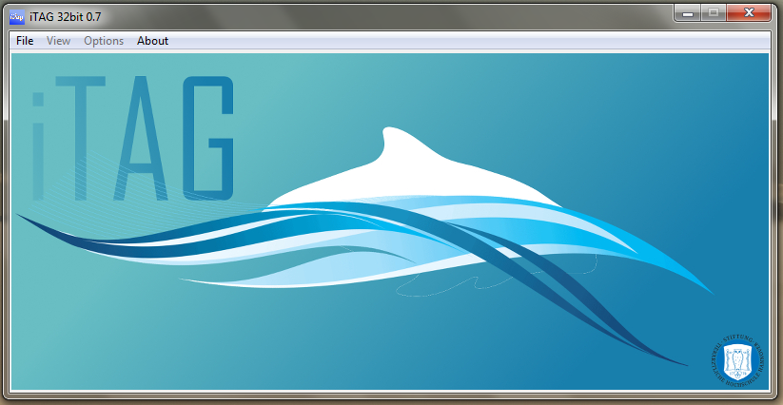

A new session wizard will open, which will guide you through your session setup. The session wizard loads the default settings from disk, however, you can always specify a previously saved option file and later define this as your new default file. You can always refer to factory default settings by clicking ‘*load factory defaults*’. On the first slide, you will be prompted to enter your username. Characters that are not allowed will not be displayed. The username in combination with the information from the photographs will then be used to organize the output on your computer.

On the next slide, you can enter up to 9 generic parameters that could describe the specifics of your survey, e.g. the type of vessel you used, the weather conditions etc.

**Note: while theses parameters will be saved upon ending the session, they will not appear in any table. However, the *sqlite* database file will hold a table containing these info.**

The next slide will prompt you to specify the image directory. You can click on ‘*Choose Directory*’ and select the folder that contains your images.

**Note: you should create a folder (such as one folder per survey day) and put all the images as JPG or BMP files into that folder. iTAG will not parse subfolders and will not identify duplicates!**

Upon successfully loading the images from the directory, a small summary of the files is displayed within the wizard.

**Note: If you are planning to use very large images, it is best practice to use the bitmap format (fles ending in .bmp). See also FAQ section.**

In the next Wizard slide, you can further set up the categories and modifiers that will be available during your session. You can define up to 9 different categories and modify the text that is associated with the modifier keys.

**Note: If you don’t want to use some of the modifiers, just keep them as they are (but avoid duplicate modifier names). Duplicate category names will later be replaced by modified category names.**

By clicking on the coloured button next to each category, you can then pick a colour for the category. iTAG provides distinct colours for 9 categories, but in case you decide to modify these colours, iTAG will warn you if you pick a colour that is very similar to another existing colour. You will still be able to use similar colours!

The last slide will then give you a short summary of your setup and offer you to save this specific setup as the default session setup (excluding the directory name) or as a specific setup file you can reload in future sessions.

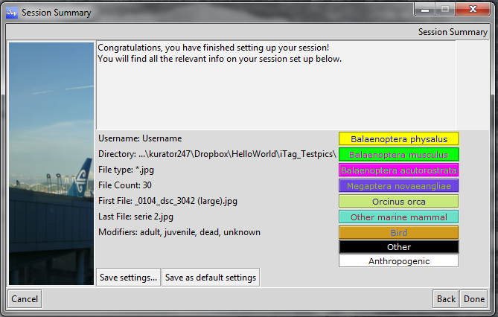

Upon clicking ‘*Done’*, your session will start immediately.

### RESUMING A PREVIOUSLY SAVED SESSION

Once you have a saved session on your computer, you can resume at any time by clicking ‘Resume Session (Ctrl-O)’ or by clicking *File -> Resume Session (Ctrl-O)* or by simply pressing *ctrl + O*. A file browsing dialog asks you to select a previously saved session.

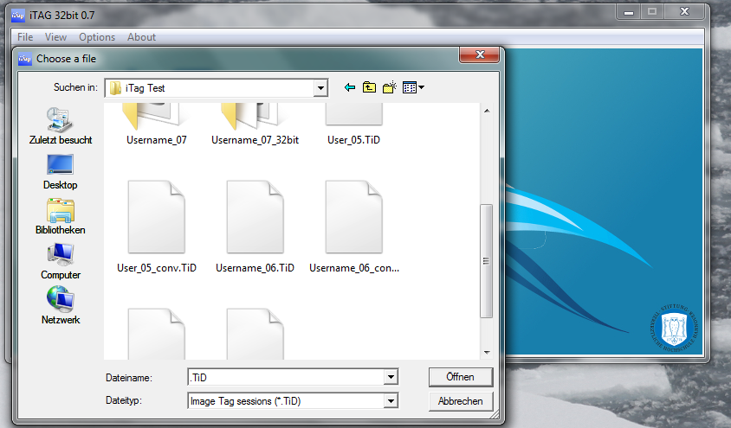

As of version 0.7, the default file ending for iTAG session files is ‘*\*.iT7’*. If you want to load sessions from older files, you will have to select ‘*previous iTAG version (*.TiD)*’ from the drop down menu. Once you have selected the session file, iTAG will load the session and you will be able to resume the session.

In case that you load up a saved session from a previous version (starting from Version 0.5), iTAG will attempt to automatically recover that session and transfer the save data into a new session.

**You will still have to save the converted session manually, as iTAG will never destroy your old sessions!**

In case that the folder saved within the save file does not exist anymore, iTAG will prompt you to select the new location of the folder. If then found, iTAG will compare the content of that folder with the images previously saved and warn you in case of missing images.

As long as at least one image in the saved file was found in the new folder, iTAG will open the session. If any file is missing, iTAG will warn you about the number of missing files and their respective filenames. If none of the previous files can be found, iTAG will ask you if you would like to try a data dump of the tag data, if available. In this case, iTAG will try to export the tag data into a *sqlite* file within the save file’s folder and, if desired, the same csv tables as during the end of a session (see also 6.4.3).

## MAIN INTERFACE

Upon loading the first image, you are presented with the main interface window showing the first image.

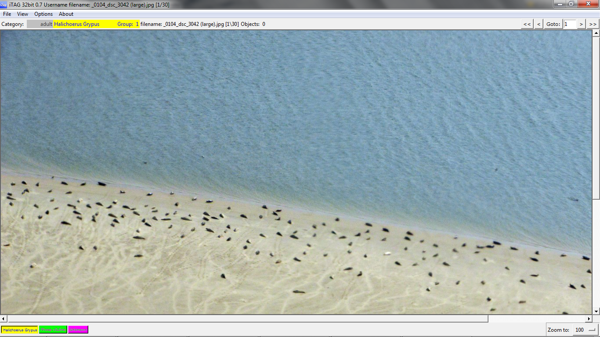

You will notify distinct elements on the screen.

First, let’s start with the menu bar:

The File Menu lets you save and end your session:

* Save Session (*Ctrl-S*): Save your current session in order to have a well-earned break from clicking
* End Session (*Alt-Q)*: Ends the current session and, if any tags had been placed, asks the user whether the session should be saved

The view Menu includes the following check buttons:

* ‘*Show General Panel (F9*)’: toggles a panel displaying various information on the current image (see 6.3.6)
* ‘*Switch to full screen (F11*)’: toggles between full screen and windowed mode
* ‘*Show group identifier on tags (F12*)’: toggles the display of group membership on the tags on or off

The Options Menu offers the following settings:

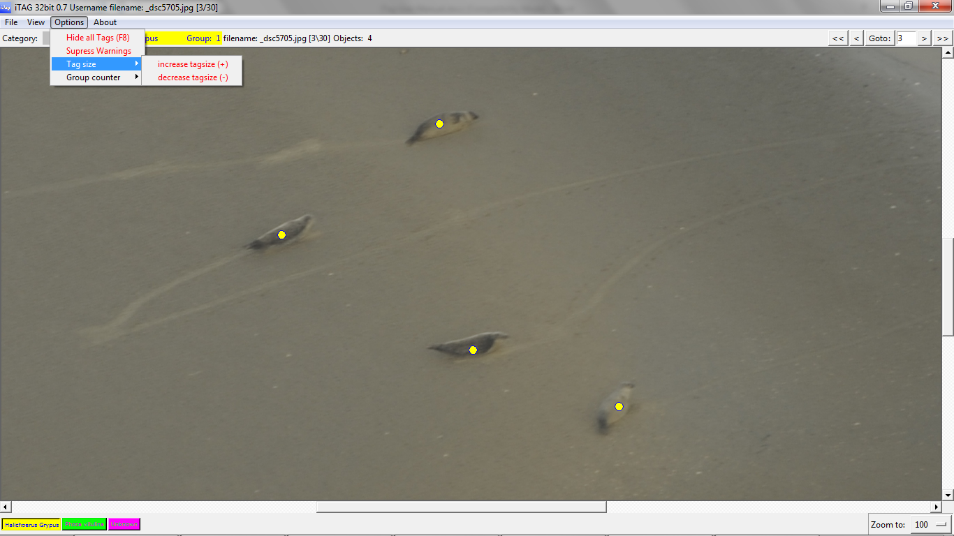

* ‘*hide all tags (F8)*’: toggles the display of all tags currently visible on the image on / off.

**Note: You cannot add or remove tags while tags are hidden from view**

* ‘*Supress Warnings*’: toggles warnings for duplicate tags on or off. The warnings get reset when you change images

The sub menu *Tag size* includes the following items:

* ‘*increase tagsize (+)’*’: increases the displayed tag size
* ‘*decrease tagsize (-)’*: decreases the displayed tag size

The sub menu *Group counter* includes the following items:

* ‘*increase group counter (e or Up Arrow)’*’: increases the group counter for the current species
* ‘*decrease group counter (d or Down Arrow)’*: decreases the group counter for the current species

The next part of the window displays a status bar which shows the currently selected category, the current group identifier for the next tag, the current filename of the image, in square brackets the file number / total number of files and the number of objects tagged so far. There are also controls that allow the user to quickly access pictures by either browsing to the beginning of pictures (<<), the previous picture (<), the next picture (>) or the last picture (>>). In addition, you can simply provide the image number you want to see and click ‘*Goto*’.

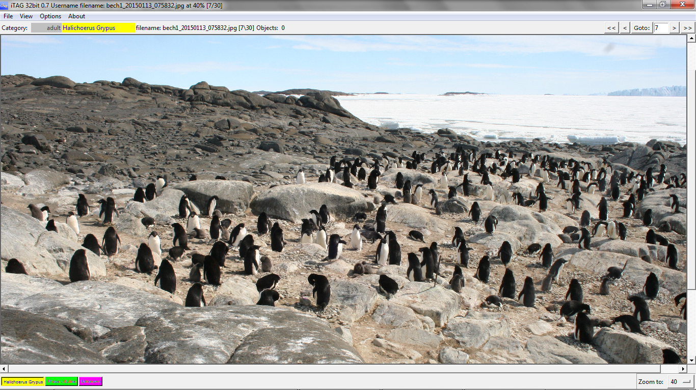

The largest portion of the screen is reserved for the actual image display. To the bottom and the right of the image are rulers, in case the images are larger than the available screen space.

The bottom gives you a short overview of the available categories in ascending order (1 through 9) and their respective colours. You can also set the scale of the window by clicking the button next to the ‘*Zoom to:*’ feature at the bottom right hand of the screen and select an appropriate zoom factor. It is easier if you keep the mouse button pressed and then select a scale. The selected zoom factor will be saved per file and will be applied as soon as you browse to that image again.

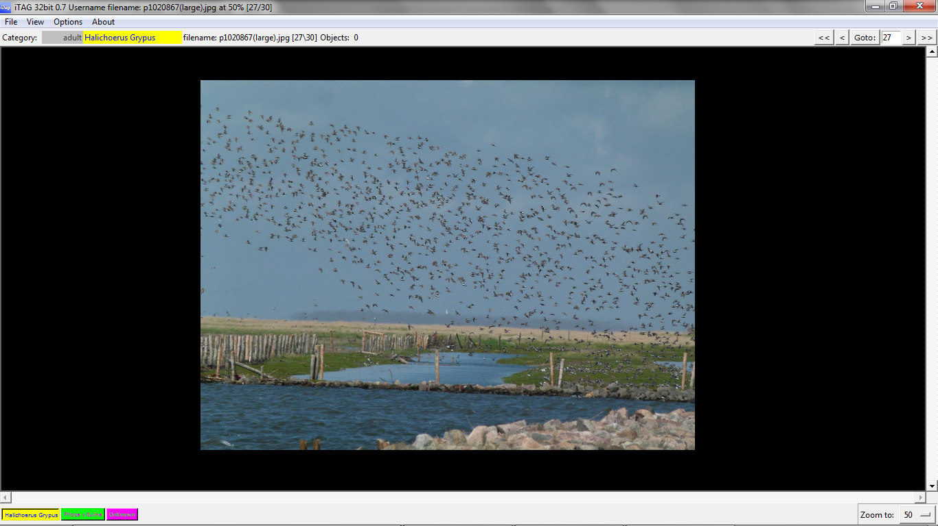

### MOVING AROUND THE IMAGE

Panning the image is straightforward: simply left click and hold the mouse button, then move the mouse around. Additionally to displaying various info on the current session, you can simply left click anywhere in the preview picture within the General Panel (activated by either clicking the button ‘*Show General Panel (F9*)’ or by hitting the *F9* key) to jump straight to that position.

### TAGGING OBJECTS

Tagging objects is as straightforward as selecting a category by pressing 1 through 9 (depending on the number of categories you have defined) or clicking the category buttons at the bottom of the screen, positioning the mouse above the target object and right clicking the mouse. iTAG will display a warning window when you place a new tag very close to an existing one (**however, the tag will still be placed**). By clicking *View -> supress warnings*, all such warnings are suppress until the image changes.

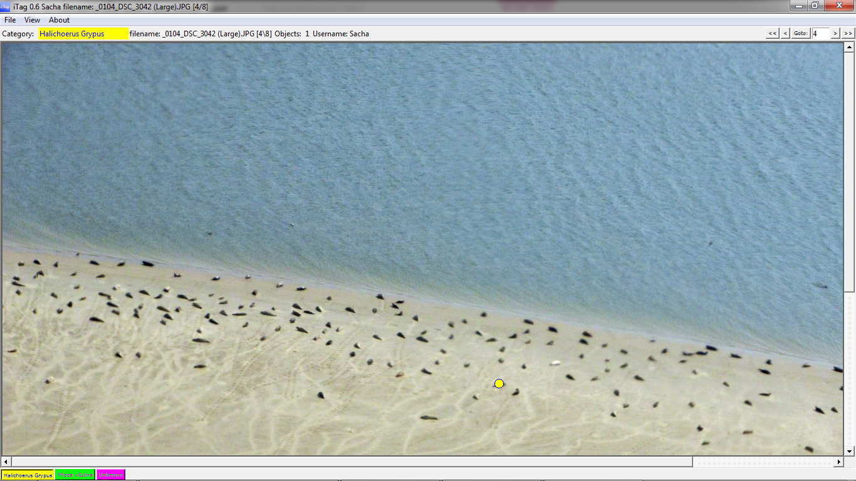

### TAG MODIFIERS

When right clicking, you can use modifiers with each tag, as defined in the session options at the beginning. Per default, these are:

* No modifier: ‘adult’
* *shift* Key: ‘juvenile’
* *ctrl* Key: ‘swimming’
* *alt* Key: ‘dead’

In the example below, you can see that we have tagged multiple adult grey seals (*yellow circle*, yellow being the colour for grey seals and the circle being the symbol for adult animals). Additionally, by holding down the shift key while right clicking the animal, we’ve also tagged two juvenile grey seals and one lonely juvenile harbour seal (*green square*; green the colour for harbour seals and square as symbol for juvenile animals). 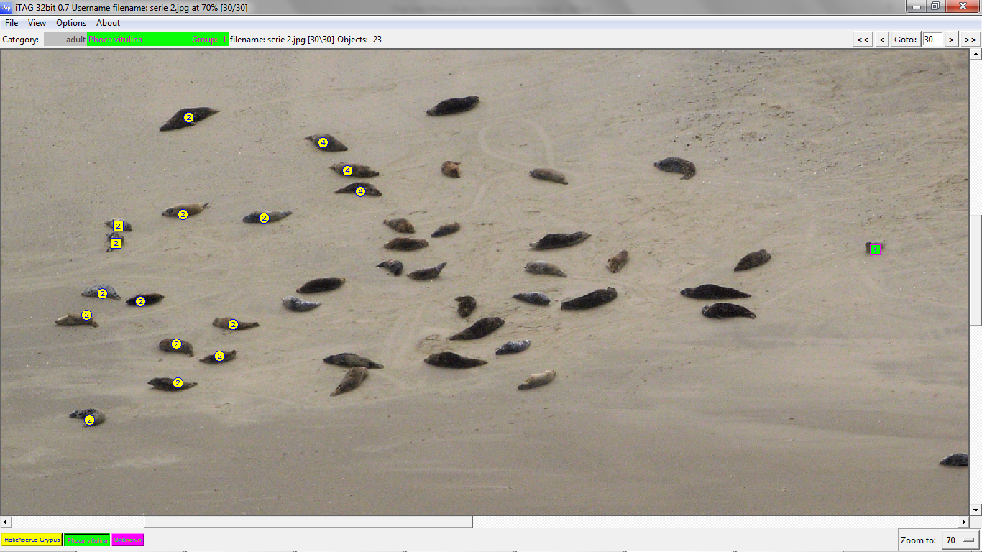

The use of these symbols is strict and is as follows:

* circles: no modifier
* squares: *shift* modifier
* hollow squares: *ctrl* modifier
* horizontal bar: *alt* modifier

You will also notice that I’ve assigned different groups to some of the animals, indicated by the numbers on the tags (activated by pressing *F12* or clicking on *View -> Show group identifiers on tags*).

**Note: Some users may accidentally hit the Caps Lock key. In order to prevent that, iTAG will immediately switch the Caps Lock off again. Depending on your PC configuration, you may still see some pop up or notification that shows the toggle of Caps Lock, but you can ignore that.**

### REMOVING A TAG

If you want to remove a tag, press *x* and you will enter erase mode. This is also indicated by a red **ERASE** notification in front of the category identifier within the status bar and a changed cursor icon. In order to erase a tag, you’ll have to select the same category as the tag to be removed and then right click near the tag you want to remove. iTAG will never remove a tag from a category different from the currently selected one.

### MAGNIFIER MODE

As an additional tool, you can activate the magnifier tool by pressing the ‘*m*’ key. This will display a cropped version of the image next to your mouse pointer that you can zoom into using the mouse wheel.

**Note: existing tags will NOT be displayed within the magnifying tool!**

In addition, you can add various image filters to the magnifying tool by pressing the appropriate button:

* g: switches on/off solarised filter
* h: switch on/off the equalised histogram filter
* j: switches invert filter on/off
* k: switch on/off the autocontrast filter
* l: switches on/off posterised filter
* u: switches on/off unsharp filter
* s: switches on/off smart sharpen filter (CPU intensive feature)

### THE GENERAL PANEL

After toggling the general panel, you will see a floating window displaying a scaled down version of the current picture. Upon left clicking on the panel picture, you will quickly pan to the selected area as indicated by the rectangle. There are two additional buttons below the panel image:

* Gps panel: Toggles display of an additional panel containing the spatial metadata of the current image file (if available in green, else displayed in red). If the coordinates are displayed in green and you click on the coordinates, a browser window will open and display the position on Google MapsTM
* Info panel: Toggles display of an additional panel containing the summary of the session

### SAVING THE SESSION

At any time, you can select ‘*Save Session (Ctrl-S)*’ by clicking *File ->* *Save Session (Ctrl-S)* or simply hit *ctrl + S* in order to save your current session in a single file named using your username and the *‘.iT7*’ suffix. You can also modify the filename. You can resume from this file any time you want to.

### A FULL SESSION IN PROGRESS

In the following image, you can see what a full session might look like (in this case, as is advisable for very large images, using the 64bit version of iTAG 0.7). The source image was kindly contributed by Dr. David W. Johnston from Duke University and shows a mosaic from drone images of grey seals in North America at about 13,000 x 6,000 pixels (Image courtesy by Duke University Marine Lab). The general panel is switched on and shows a small preview image to ease navigation. The tag summary panel (*F9*, then click on *Tag summary*) is visible, indicating that I’ve tagged 29 adult and 4 juvenile *Halichoerus grypus* in the image (so far). I’ve also enabled magnifier mode (using the *m* key) and used the solarization option (*g* key) to make some grey seals more detectable. You can also see at the top that this is the first of 6 images loaded into the session. Again, I have switched on the group display (by either hitting the *F12* key or by clicking on *View -> Show group identifier on tags*). The Navigation Panel (activated by hitting the *F9* key or by clicking *View -> Show General Panel*) shows you that this image does not supply GPS information (as indicated by the red entries in the File Info Panel).

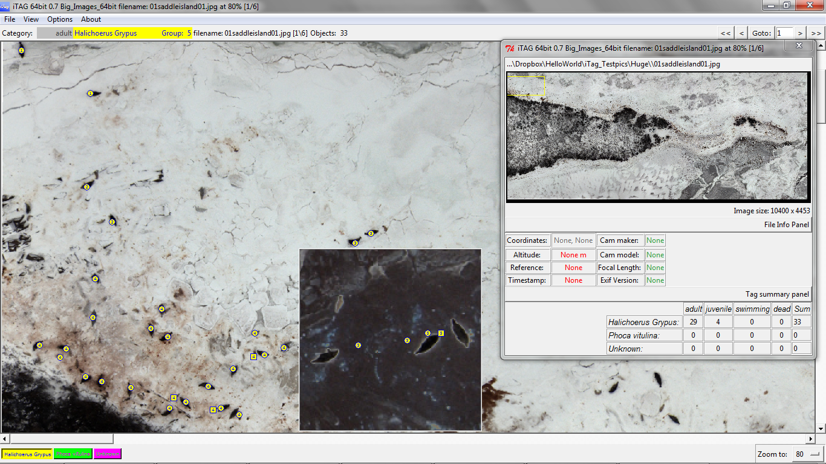

## ENDING THE SESSION

Once you have tagged all the animals and are satisfied with the tags, you can click on ‘End Session (Ctrl-Q)’ or press *control + Q* to display a save dialog and trigger the processing of the tagged images. As when saving in during a session, a single file (ending on .iT7) will be generated, allowing you to resume / review your choices anytime. Within the Output Options window, you will then be presented with various output options described in detail below.

### COLUMNS TO PROCESS

You can select the categories / modifiers combinations you want to see in the summary by either clicking on the corresponding check button to select or deselect a modifier / category combination or by simply clicking on the modifier name to unselect / select a complete modifier.

**Note: This only applies to the summary table. The detailed table and the *sqlite* database will not be affected by this decision.**

### PROCESS IMAGES

By checking this value, tagged images will be produced within the ‘*Images’* subfolder of the output directory. Per default, iTAG will create scaled down jpg image files for each image containing the tags you’ve placed for future reference and archival. Also, a legend image is produced.

### CREATE CSV FILES

A database file will always be produced. However, you can also create spreadsheets of each database table. Per default, iTAG will create multiple colon separated files in a subfolder called ‘*Tables*’ (using a point decimal separator). If enabled, iTAG will produce a detailed table that contains info on each individual tag and an aggregated summary table that collates tags on each image. You can choose the column separator via the dropdown Menu.

**Note: The summary file will only contain the previously selected combinations of modifiers and categories.**

### CREATE GOOGLE EARTHTM KML FILES

You can toggle the creation of a KML Layer that you can display within Google Earth. If you chose to export your tagged images, all images that had been tagged and that included spatial information are displayed upon loading the KML file into Google EarthTM.

**Note: The KML file does not include the Images, it’s just referencing them. As long as the images are within the Images subfolder, the images will be displayed correctly. If you share the KML file without providing the images, the images will not display properly within Google EarthTM.**

### CREATE SQL FILE

iTAG will try to create a native SQL dump of the database. You can import this file into any existing database that uses the SQL standard (feature is currently deactivated).

# KEY REFERENCES

**Note: A ‘+’ sign indicates that both keys / mouse strokes have to be performed simultaneously. LMB / RMB indicates a left / right mouse button click.**

## KEY REFERENCES - SESSION SETUP

|  |  |
| --- | --- |
| **Key** | **Function** |
| *Control + N* | Start a new session |
| *F1* | Display help page |
| *Control + O* | Load session (resume previously saved session) |
| *Control + Q* | Exit iTAG |

## KEY REFERENCES - MAIN INTERFACE

|  |  |
| --- | --- |
| **Key** | **Function** |
| *Control + S* | Save the current session |
| *Control + Q* | End session |
| *1 through 9* | Select category (number of categories depends on session setup) |
| *RMB* | Add tag at cursor location |
| *Shift + RMB* | Add modified tag (*shift* modifier) |
| *Alt + RMB* | Add modified tag (*alt* modifier) |
| *Ctrl + RMB* | Add modified tag (*ctrl* modifier) |
| *x* | Enter eraser mode; right click near tag to remove tag |
| *LMB + drag mouse* | In main interface image: Navigate image |
| *w or ← (arrow key left) or a* | Go to previous image |
| *q or → (arrow key right) or z* | Go to next image |
| *+ (plus key)* | Increase tag size display size |
| *- (minus key)* | Decrease tag size display size |
| *e or ↑ (up arrow key)* | Increase current Group counter |
| *d or ↓ (down arrow key)* | Decrease current Group counter |
| *m* | Switch magnifier mode on / off |
| *F1* | Display help page |
| *F8* | Toggle tag display |
| *F9* | Switch general panel on / off |
| *LMB* | On panel image: navigate image |
| *F11* | Toggle Full screen |
| *F12* | Toggle Group ID display |

### KEY REFERENCES - MAGNIFIER MODE

|  |  |
| --- | --- |
| **Key** | **Function** |
| *g* | Switch solarized mode on / off |
| *h* | Switch equalized histogram on / off |
| *j* | Switch inverted image on / off |
| *k* | Switch auto contrast on / off |
| *l* | Switch posterize filter on / off |
| *u* | Switch unsharp filter on / off |
| *s* | Switch smart sharpen filter on / off |
| *Mouse Wheel up / down* | Zoom in / out |

# FAQ

**Q: Where do I get the new version of iTAG from, again?**

A: You should get it from <https://sourceforge.net/projects/itagbiology/>. Not only will you make me feel proud by increasing the number of downloads, you will also make sure that you have the latest version of iTAG.

**Q: Is iTAG free to use in any scenario?**

A: Yes, and no. It’s actually very simple. I believe that no scientist should waste their time with clunky software just because they are not able to produce their own tailored software package. I happened to create a quite flexible software that seems to work for many people, and I am very glad that it has been accepted so positively. If you feel like iTAG helps you achieve your goals and is the one thing that you’ve been looking for, I am perfectly satisfied. So if you present any results that you have obtained using iTAG, be fair and say so. If you liked it and plan to use it in future studies, advertise it to your colleagues and tell them to download it from sourceforge (see above question). While there is still not a ‘peer reviewed’ reference that you can use for reference, any advertisement and any feedback (positive and negative) will encourage me to work on a publication.

**Q: Is there a limitation to the number of Images I can load / the number of tags I can create?**

A: In theory, there is. However, the number depends on the amount of free space on your hard drive (as all tags are stored on the drive and not in your ram) and thus will usually exceed a couple million tags. The number of images only depends on the architecture of your PC. If you want to be on the safe side, use the 64bit version of iTAG and make sure that you have a huge amount of RAM.

**Q: I have access to fancy new technology that produces images at resolutions of more than 10,000 by 10,000 pixels. What now?**

A: I am glad that you can use such tools. However, you will need a good PC to process these images, and luckily, as of version 0.7, iTAG also comes in 64 bit. If you are working with very large images, you should check whether your PC configuration and session setup matches the following criteria:

1. You should have a lot of RAM at your disposal (I’d say 8gigabyte is the minimum)
2. You should have a 64bit CPU and a 64bit operating system (in order to use the excessive amount of RAM)
3. You should make sure that reading / writing from disk is acceptably fast (I would recommend a SSD drive)
4. You should use the 64 bit version of iTAG
5. To be on the safe side of things: you should setup single image sessions, i.e., load one image file per session. iTAG uses python, python is bad at handling memory exceptions. Crashes can come suddenly, especially if you try to load a new image while the old one has not yet vanished completely from RAM.

You should also test if uncompressed images (i.e. in bitmap format, ending in *‘.bmp’*) work better. These are surprisingly less demanding on your ram!

**Q: I have saves from versions 0.5 and 0.6. Can I still use them?**

A: iTAG will try to convert these old files into the new format. However, I can’t tell what funny things you did in those old sessions, so there is no guarantee that everything will be converted. To stay on the safe side, just keep the old versions of iTAG on your PC (they are only at about 19 megabytes).

**Q: I have an old save but the images are gone. Do I have to redo everything?**

A: Usually, iTAG will ask for a new directory when encountering missing files. iTAG will switch into a Recovery mode when no new file location is supplied. I would recommend ending the session and unchecking the export images option, that way you should get the database file as long as your tag data is present. Since version 0.6.1, Recovery mode is clearly marked as such on the main window and leads the user towards possible recovery solutions.

**Q: iTAG fails to load images even though I know that I have provided the right location!**

A: You should check for bad characters in your directory and filenames. Bad characters are special characters like ü, ö, ä or *~#. This is usually the most common reason why any file load operation may fail.

**Q: Sometimes there is a smaller widow visible before another window with content opens. Is something wrong?**

A: No. It’s just something I can’t figure out. When I have found out what causes this flicker, I will have it fixed!

**Q: How do I actually make sense of the group counters? It is not a very intelligent feature!**

A: True, you’ll have to use it carefully. As of now, there is no mechanism to prevent you from falsely assigning groups to tags. Use it according to your own research interest: Look at the number next to the category and keep the group id display switched on.

**Q: Can you select multiple tags and edit them instead of having to delete them?**

A: No, not yet. But it is on my agenda for the 0.7 releases.

**Q: I would like to see some features that I find useful – where are they?**

A: Well, as long as they are only living inside of your head, there will be no change – contact me through sourceforge or [itag.biology@yahoo.com](mailto:itag.biology@yahoo.com) and make your suggestions and ideas heard! You can also check on sourceforge which milestones I’ve set up for the future and, in case your feature request is not included, you can make a polite suggestion to include that one life saving feature of yours!

**Q: How do I cite iTAG?**

A: So far, this will be the only option:

*Viquerat 2015 (Conference Poster)*

*An open source software facilitating the analysis of count data from still images*

*29th Conference of the European Cetacean Society, Malta, 2015*

Keep supporting me with downloads and feedback on sourceforge (<https://sourceforge.net/projects/itagbiology/>) and I will start working on a thorough publication!